CURRICULAM VITAE

SUKESH.S
CHANDRALAYALAM
AMBALATHU NADA
MUKKOLA PO
TVM
KERALA
INDIA
PIN:695043

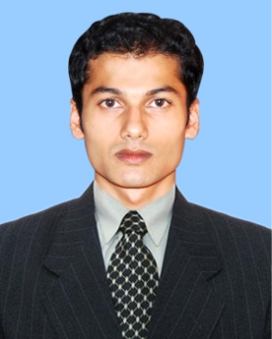

E-mail: sukeshanimaster@gmail.com
Phone: 09995393283

OBJECTIVE

Seeking a challenging and growth oriented career in a better atmosphere and to become a contributing member utilizing educational background and experience to achieve and surpass corporate and personal goals mutually.

PROFESSIONAL STRENGTHS AND SKILLS

- Comfortable and efficient in creating 3D Models using Maya also eager to learn new software’s and progress faster.
- Confidence.
- Disciplined.
- Obedience.
- Punctuality.

ACADEMIC PROFILE

- Plus two passed from Board of public Examination in the Year 2007. (ST:JHONES Model H S S,Nalanchira).
- Deploma in computer operator ITI(N.C.V.T)
- Animaya PRO in AKG Institute of Information Technology (1Year course in Maya) Animation Academy in Trivandrum
- 3D Visualization in AKG Institute of Information Technology ( 6 months course in 3Ds Max and V-ray.

SKILL SETS

Software known
- WINDOWS 98/XP/Vista/ Win 7
Knowledge with Graphic packages such as
- Photoshop, CorelDraw, Adobe Illustrator,Page maker
Knowledge with Animation Packages
  - Flash, Maya, 3ds Max, Adobe Premier , Sound Forge. After Effects
Knowledge with 3D Engineering Designing
  - 3ds Max(V- Ray and Mental ray), Auto Cad
Knowledge with Hardware
  - Knowledge of assembling and servicing Computers

EXTRA CARRICULAR ACTIVITIES

- Free land GRAPHICS & Editing WORK.
- Best Actor & Script Writer in DRAMA at district level youthfestival
- 1st prize in Painting & Pencil drawing at district level youthfestival

LANGUAGES KNOWN
Malayalam,English,Hindi ,Tamil

PERSONAL INFORMATION

Nationality : Indian
Religion : Hindu
Father’s Name : Suresh Kumar B
Age & Date of Birth : 22, 15-01-89
Sex : male
Martial Status : single
Permanent Address CHANDRALAYALAM
AMBALATHU NADA
MUKKOLA PO
TVM
PIN:695043
HOBBIES
Cartoon Drawing, Reading, Watching Movies, Playing Sports (Cricket).listening music.

Produce portfolio on request:

DECLARATION

I here by declare that the above statements are true of the best of my knowledge and beliefs.

Thiruvananthapuram SUKESH.S

